**TECHNOLOGY NEWS SITE**

DESIGN DOCUMENT  
  
 **Web Creation Boot Camp, DGM6501  
Adithya Chowdary Maddipatla  
  
Guided by  
Prof. Velda Shaby  
March 31st, 2024**

**Table of Contents**

1. Introduction…………………………………………………………………….3
2. Navigation……………………………………………………………………….4
3. Directory structure………………………………………………………….5
4. Wireframes……………………………………………………………………..6
5. Site map…………………………………………………………………………..7
6. Font………………………………………………………………………………...8
7. Colour scheme…………………………………………………………………9
8. Sources and references…………………………………………..………10
9. Conclusion………………………………………………………………………10

**1. Introduction**  
  
This design document outlines the process of creating a website that highlights the most recent technological achievements and breakthroughs that have significantly improved our quality of life over the past ten years. In the quickly changing digital landscape, both individuals and companies must be informed of the key technological advancements to be relevant and competitive. Staying up to date with evolving technology allows one to take advantage of development opportunities, embrace new tools, and speed up operations.  
  
**A brief overview of the website's technological components:** To maintain contrast and intelligibility, I would use a sans serif font—or a typeface similar to it—for all of the text, choosing black text on white or grey backgrounds and white text overlays on backdrop photos.  
Users may find trending news about technical advancements throughout the world that have had a big impact on the economy on the homepage. There's also a dashboard with user-generated tech ratings that scroll along with the user and the trending news of the month on the right. Prominent product evaluations and buying advice are a couple of the website's additional features.  
  
**Reason for picking the topic:**  
In today's world of rapid change, technology news is essential since it covers a wide range of businesses and offers insightful information to both the technical community and lay readers. You are kept up to date on any changes that may affect your firm by tech news. For example, if you run an eCommerce website or blog, an update to your page's ranking could have a positive or bad impact. New software updates and regulations may have an impact on your business. It helps to know about them in advance so you can take the necessary steps to rescue your business.  
  
**Goals:**My personal objectives for the website are to improve its User Experience (UX) and make it easier for users to access and browse. As soon as a user lands on the page, they should be able to comprehend its goal swiftly and readily. Creating an outstanding user experience requires a thorough understanding of the obstacles that different types of website users must face. I'm interested in learning more about the efficient use of text and graphics, particularly creative and well-written headlines. I'd also like to know how to utilize white space effectively.  
  
**Target audience:**  
IT enthusiasts that are keen to delve into the specifics and glean as much relevant knowledge as they can about their areas of expertise make up my target audience. Some of the users are nonetheless detail-oriented even when they hold administrative positions. They have a far greater enthusiasm for technology and are far more likely to read about tech-related topics than persons in more senior professions. The information that my target audience looks for—brands and news sites that provide useful insights and answers to the problems they face daily at work—must be communicated using real-world examples.  
  
**How do I measure success?**  
As the creator of a tech website, I would measure success in the following ways:  
**1. Higher website traffic:** A company's audience appeal can be measured by tracking website visits; higher traffic suggests that the material is engaging readers and is contributing to the development of a loyal following. My goal for the first three months would be to reach 100 daily visitors on this newly designed website with a niche audience.  
**2. Low bounce rate:** A lower statistic indicates longer stays, which may result in more visitors becoming digital customers. The bounce rate metric counts the number of users that depart a website right away. A bounce rate of fewer than 25 per day is what I would want to see.  
**3. Higher average time spent on the site:** Since more time spent on a page can suggest more interaction, content providers should regularly review the time spent on the site to make sure quality content is being given. For a newly designed website, I would like to see a minimum of 10 minutes spent on average by each user.

**2. Navigation**  
The menu at the top of the website allows you to navigate the entire site. The remaining tabs are oriented to the right of the left-aligned logo located in the top menu, which you can click at any moment to return to the homepage. When a mobile phone or tablet is used (anything less than 768px), a hamburger menu appears.  
The website contains the following elements:  
**1. Home page:** This is the home page of the website that proves that keeping up with the newest developments, innovations, and trends is crucial in a world where technology is advancing at a rapid pace. The user is welcomed with news that piques their curiosity about the always changing digital scene and how the internet is a veritable gold mine of invaluable materials.  
**2. Products section:** The user can peruse our wide selection of products in this section, each carefully chosen to fulfill their demands. Our selection includes both old and cutting-edge devices, so there is something for everyone. Explore each item's quality, innovation, and cost. For the best possible technological experience, stay up to date!  
**3. Trends section:** With our section on technology trends, which offers insights on AI, blockchain, IoT, cybersecurity, and other topics, users can remain ahead of the curve on this page. Discover ground-breaking inventions, professional analysis, and future projections that are influencing global industries. Remain knowledgeable and competitive.  
**4. Science:** The website states in this section that technology allows for practical application, while science supplies the theoretical framework. The website demonstrates the mutually beneficial relationship between scientific knowledge and technology innovation in digital platforms by fusing scientific concepts with technological tools to give information, services, and functionality.  
**5. Dedication to Innovation:** The user discovers on this page why the innovative website is dedicated to innovation. The website seamlessly provides user experiences by integrating news about cutting edge technologies. The website tries to stay ahead of the curve by offering visitors the greatest possible online experience with features driven by AI and user-friendly interfaces."  
**6. My products:** The user can look through my own products for creative solutions by visiting the website dedicated to my cutting-edge technological products. From hardware to software, learn about tools from my in-depth product reviews that are made to improve productivity, simplify tasks, and improve your experience.

**3. Directory structure**

**4. Wireframes**

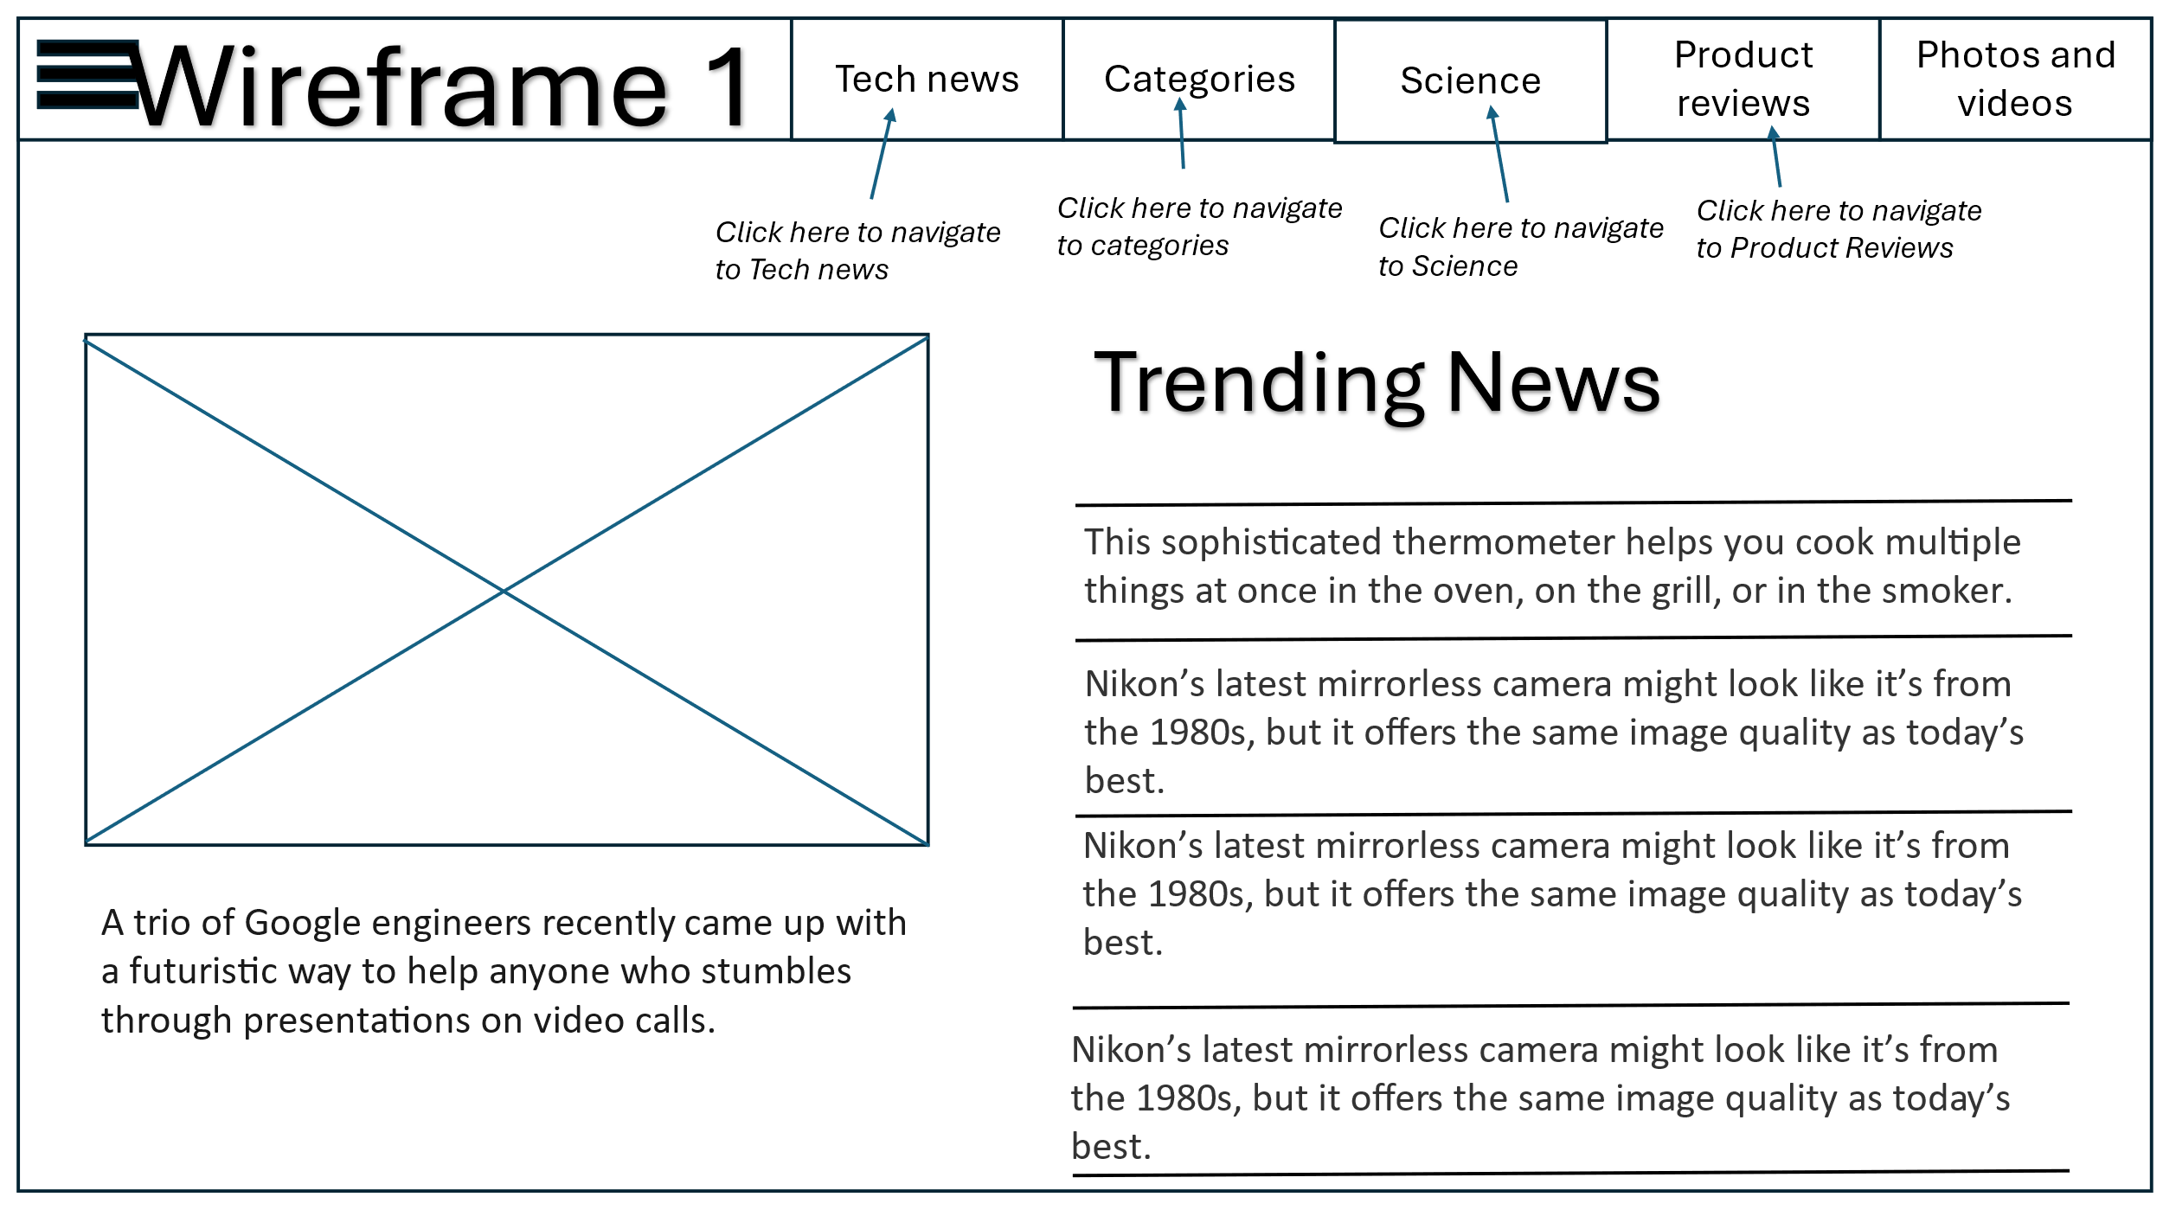

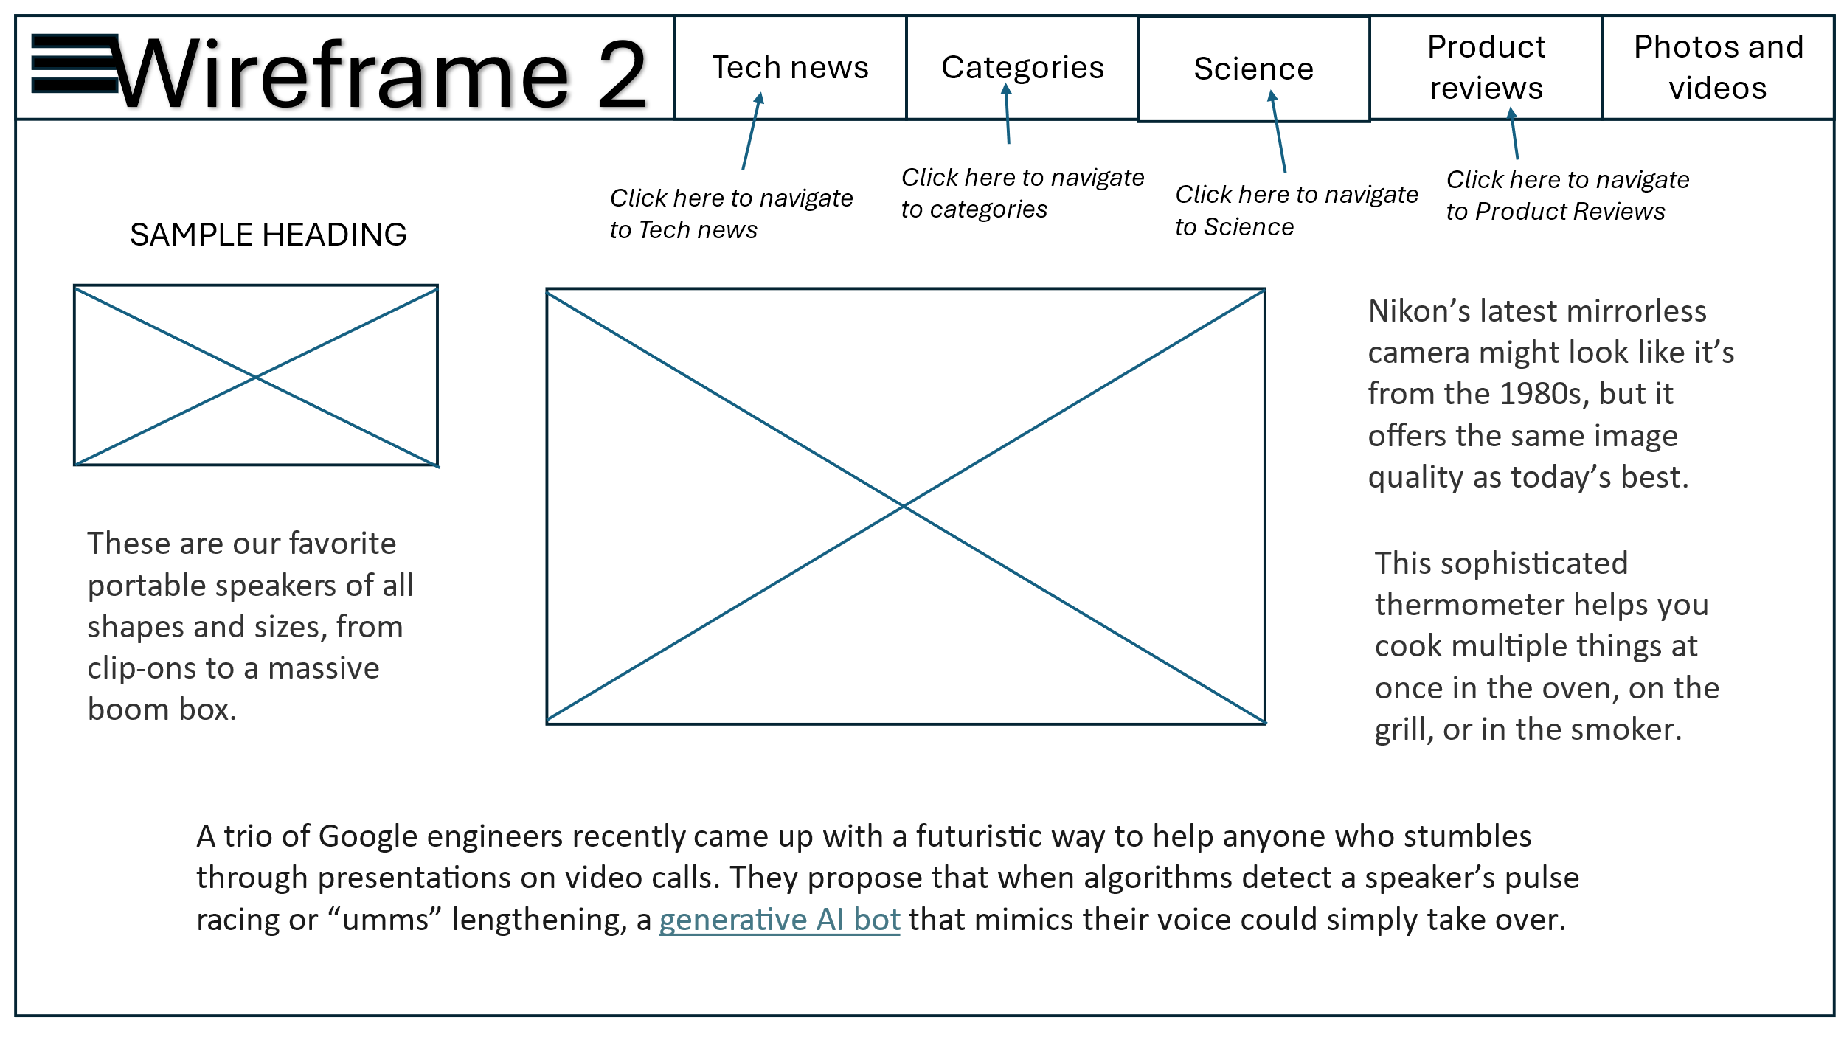

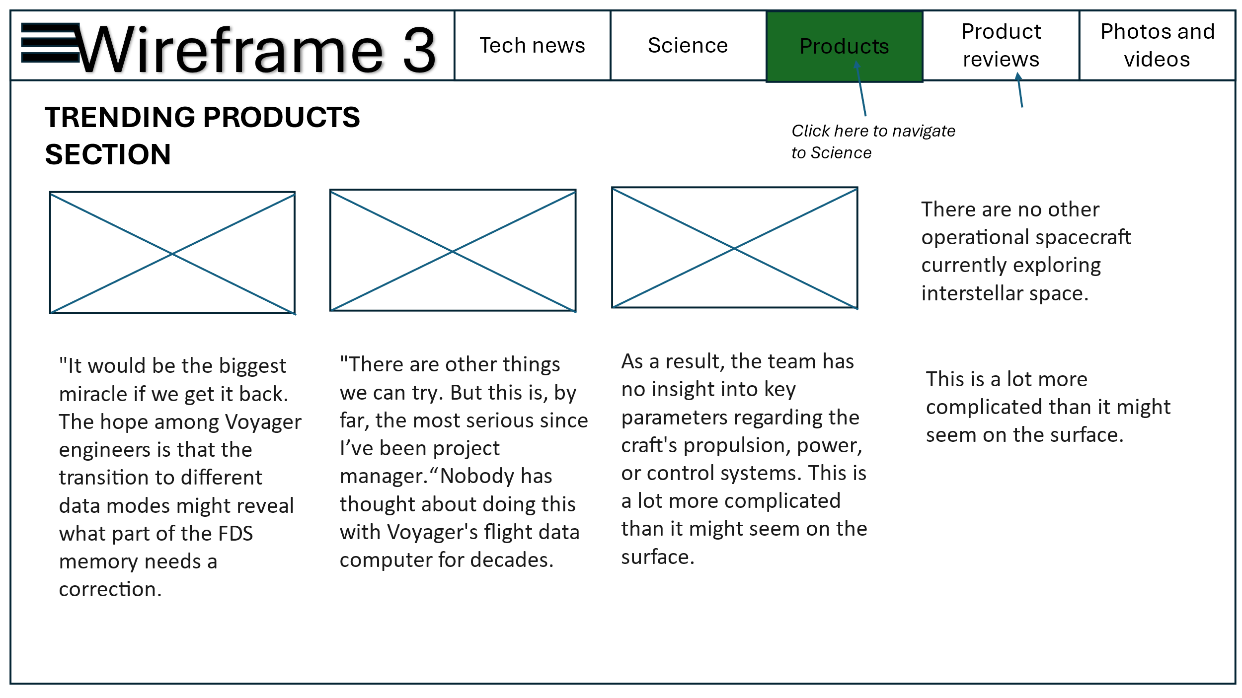

**5. Site map**

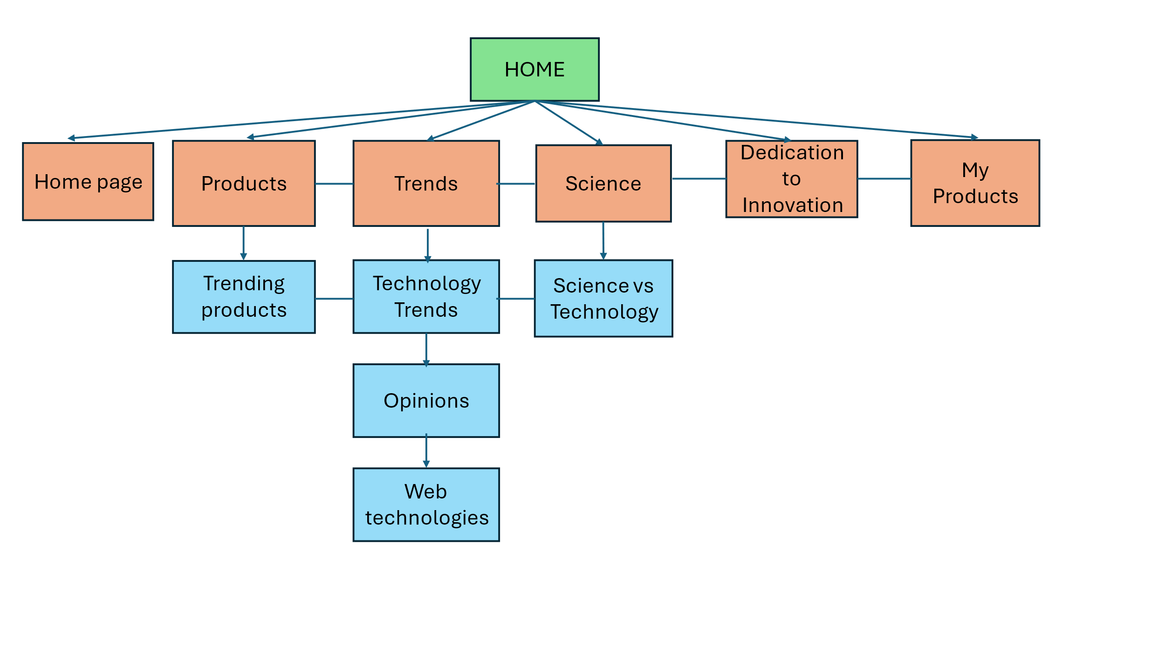

**6. Font**

1. Font: **Gill Sans**  
Font family: 'Gill Sans', 'Gill Sans MT', Calibri, 'Trebuchet MS', sans-serif;  
  
**Reasons for selecting the font.**   
The Sans font family is a flexible option for website design because it comes in a broad variety of weights, sizes, and styles. While the slab versions offer a serif choice to complement Gill Sans, the condensed versions offer greater sp1ace efficiency.  
Gill Sans is ideal for multilingual websites because it has great character support for several major writing systems, including as Latin Extended (for all European languages), Cyrillic (for Russian, Bulgarian, and Ukrainian, among others), Greek, and Hebrew alphabets.  
Gills Sans has a crisp, contemporary look that complements minimalist design. This sans serif design has a rounded corner geometric shape that gives it a casual yet polished appearance. Because Gill Sans was designed for small letter sizes, you'll frequently see it utilized as body text on websites.  
  
2. Font: **Arial**  
Font Family: ‘Franklin Gothic Medium', 'Arial Narrow', Arial, sans-serif  
  
**Reason for using this font**  
Professionals choose Arial due to its legibility; whether a logo is written on a pen or a billboard, Arial makes reading the text pleasant and easy. This typeface features natural strokes and an open style. Since every character and letter is visible, even from a distance, the reader can understand what you are trying to say. Arial is one among the most widely used options for any design element for this reason as well. Its ability to retain clarity at any size lets designers resize or reduce the size without compromising an amazing visual experience. Its adaptability and usefulness will make any reader have a pleasant experience.  
  
3. Font: **Times New Roman**  
Font family: Times New Roman', Times, serif.  
  
**Reason for using this font**Times New Roman's serifs aid in better legibility by giving the eye visual cues to follow the line of text as it moves across the page. Furthermore, Times New Roman has a comparatively big x-height, which indicates that the lowercase letters are taller than wide. The bold color scheme of Times New Roman is reminiscent of European early modern and baroque typography. Times New Roman is a typeface with a high x-height and short descenders that enable tight linespacing and a somewhat condensed appearance, as it was intended for newspaper printing.

**7. Colour scheme**

Color palette of choice for the website: **Dark grey and white**Base color: **White** (with dark grey accents)  
  
 **Reasoning behind choosing the color palette:**

In web design, a dark grey and white color scheme is common; it's quite comparable to the black and white color scheme. Typography, pictures, and other visual components may stand out more as a result. It can make user selections easier. It can present initiatives or goods in a daring, creative manner. It can do much more for your website than just make it appear polished and slick.

I want to design my technological news website with a muted color scheme. The user's eyes would strain with bold color additions because the website would include a lot of text and graphics. It would not be optimal to navigate around a page with a lot of words and pictures if the colors red, green, or blue is present. While a white font set against a black background would also be a respectable option, not everyone is used to dark themes. People may occasionally have trouble navigating or reading the content correctly.  
  
**White:** White is a color of innocence, salvation, purity, and spaciousness. In this specific instance of my technology website, I want to take advantage of the color's spatial quality.

**Grey:** The color grey is similar and closer to black which makes it a perfect choice as font color and for navigation bar. The hovering of the elements would happen in a contrast color to grey, which is similar to white.  
  
Using a grey and white color scheme might seem boring or easy — but the several website design examples prove that it’s a timeless combination that can make images and other visual elements pop, present information in a way that’s easy to read and understand, and inspire users to take action.

**8. Sources and references**  
Reference sites for HTML-CSS:

• www.w3schools.com   
• www.css-tricks.com

I also referred some YouTube videos for my hamburger menu and transparent background designing:

• <https://www.youtube.com/watch?v=U8smiWQ8Seg>  
• https://www.youtube.com/watch?v=LsyvuEegVA4  
  
  
**9. Conclusion**  
  
Initially, I harboured doubts about enrolling in the course due to my disparate background. However, I was pleasantly surprised by its intriguing and imaginative content. Immersing myself in the HTML-CSS course, I found it captivating, eagerly delving into each week's new topics and infusing creativity into my assignments. For my final project, I endeavoured to encompass every aspect covered in class, aspiring to craft a functional website for an architectural firm. Balancing professionalism with creativity, I incorporated diverse animations, photo filters, and colour effects to achieve a polished aesthetic. Reflecting on my accomplishment, I believe I successfully struck this balance, yet I aspire to enhance interactivity by incorporating JavaScript elements, a pursuit I anticipate in the upcoming quarter.   
**Challenges:**  
One of the notable challenges encountered throughout the course lay in brainstorming design concepts and approaching them from the perspective of a website user. This demanded a shift in mindset, requiring me to anticipate the preferences and needs of potential visitors to ensure an engaging and user-friendly experience. Despite the initial apprehension, navigating through this process proved immensely rewarding, fostering a deeper understanding of user-centric design principles, and enhancing my ability to create compelling digital experiences. As I look forward to expanding my skill set with JavaScript, I remain grateful for the valuable insights gained from this course and excited about the possibilities it opens for future projects.  
  
This was a pretty fun course for me. There was great flexibility in our options. There was always something new to attempt and explore every week. I had a great time at your presentations. I am very grateful to my instructor Prof. Velda Shaby for this wonderful and unforgettable experience!